May 13, 2022

Dear Editor:

My co-author and I would like to submit our manuscript titled “Implications for Determinacy with Average Inflation Targeting” to Economic Letters for publication. The paper is joint work with James Murray (UW – La Crosse).

In the paper, we utilize a standard representative agent New Keynesian model to study the implications of how constructing the average inflation target measure has on determinacy. In particular, we examine backwards and forwards looking measures of average inflation targeting (AIT), as well as the implications from naïve vs rational agents, and how parameters in the Taylor rule impact determinacy.

I am uploading a copy of the manuscript without any references to the authors on the title page. Please do not hesitate to contact me if you have any questions.

Thank you for considering our work.

Kind regards,

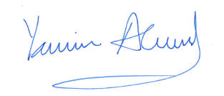

Yamin S. Ahmad

Professor, Dept. of Economics

University of Wisconsin - Whitewater